<https://stackoverflow.com/questions/40241843/failed-to-start-bean-documentationpluginsbootstrapper-in-spring-data-rest>

<https://springdoc.org/>



## Swagger jars

<dependency>  
 <groupId>io.springfox</groupId>  
 <artifactId>springfox-swagger2</artifactId>  
 <version>2.7.0</version>  
</dependency>  
<dependency>  
 <groupId>io.springfox</groupId>  
 <artifactId>springfox-swagger-ui</artifactId>  
 <version>2.7.0</version>  
</dependency>

## Swagger issue solution

spring.mvc.pathmatch.matching-strategy = ANT_PATH_MATCHER

## Java configurations

1. keep this sannotation on any config class -- @EnableSwagger2
2. configure this bean to spring context

@Bean  
public Docket swaggerApiConfig(){  
 System.*out*.println("swagger bean is getting created");  
 return new Docket(DocumentationType.*SWAGGER_2*).select()  
 .apis(RequestHandlerSelectors.*basePackage*("com.edureka.controller")).build();  
}

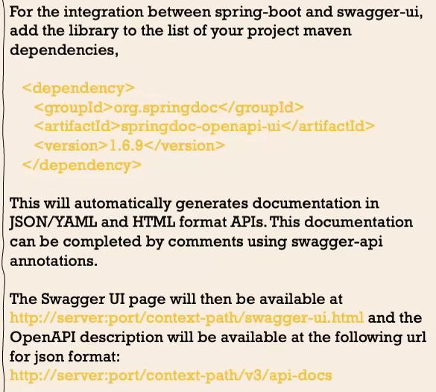

# NO need to learn open API

Generally we don’t need to learn entire open api, but if u already wrote controllers everything.. if u still want the open api spec

Just add the above jar api yaml file will come automatically